Testing text output
See if chunk options like tidy, prompt and echo, etc work as expected.

A normal chunk
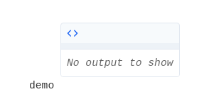

Do not evaluate
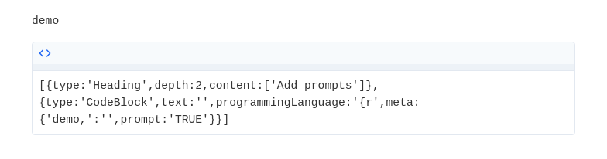

No evaluate or tidy
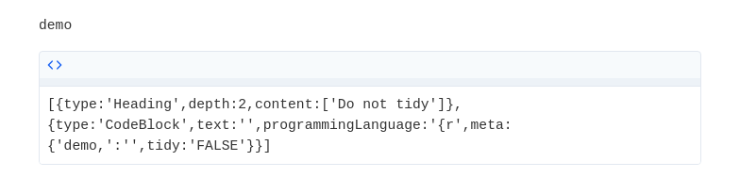

Do not echo
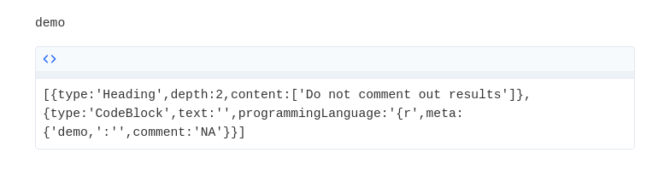

Do not echo the 2nd expression
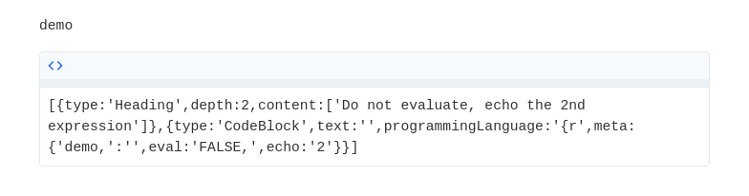

Only evaluate the first two expressions
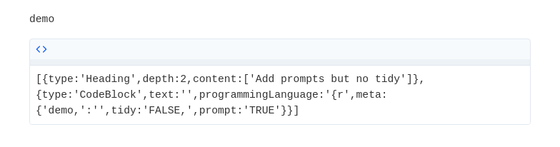

Prompts, no evaluate or tidy
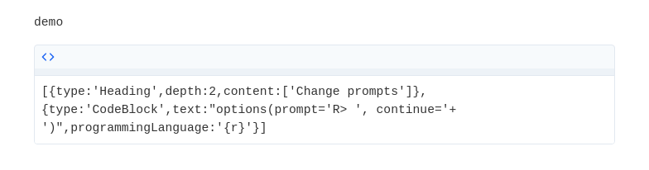
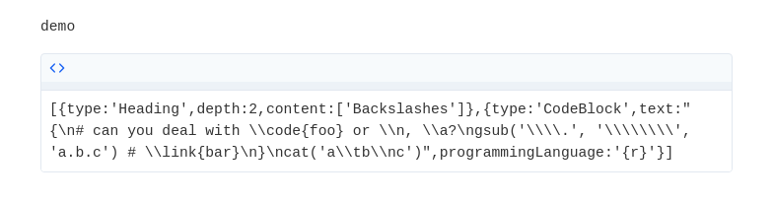

Other formatR options
We can set formatR options globally:
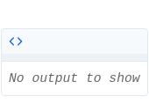
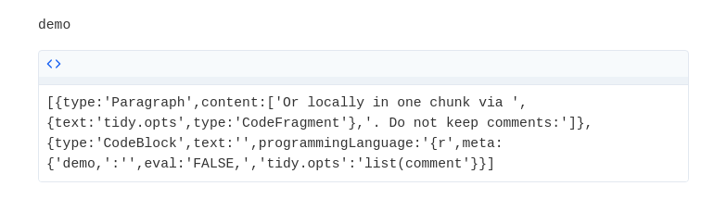
Move left braces to the next line:
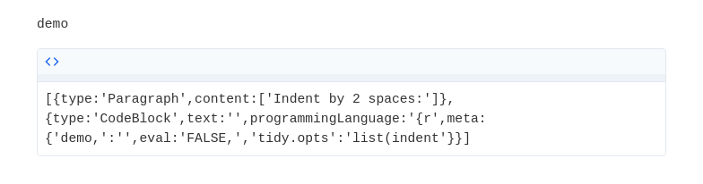
See http://yihui.org/formatR for details.

Empty chunks
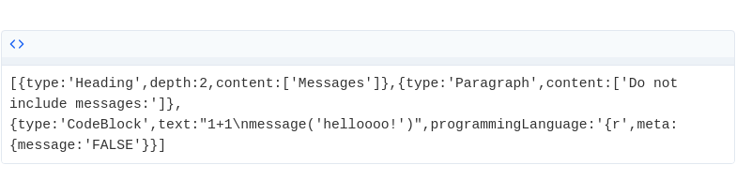
No warnings:
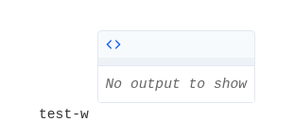
Select warnings using numeric indices:
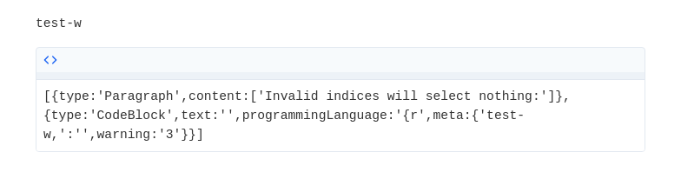

The results option
Do not show text results:
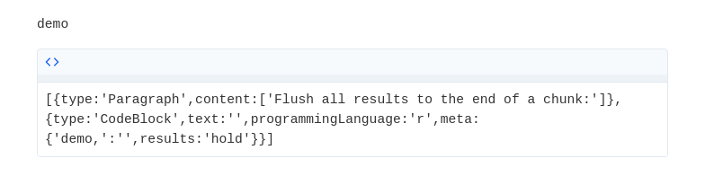
Output as is:
